Spring Data REST in Spring Boot

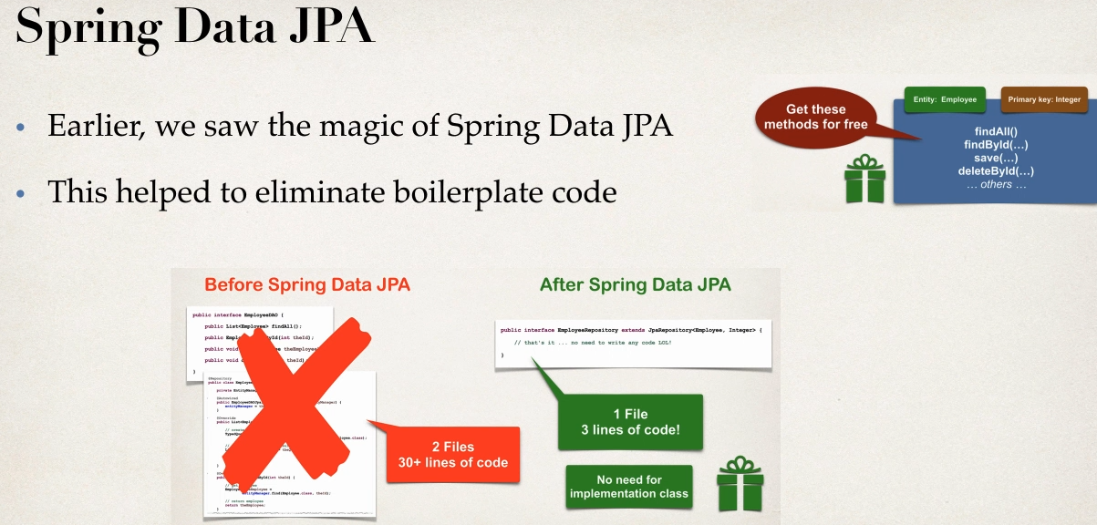

Can we apply same to REST API’s?

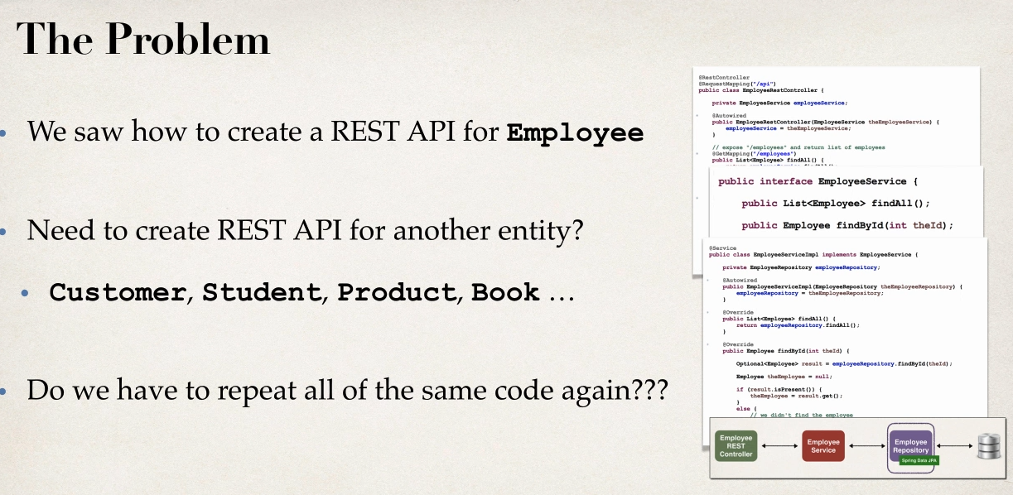

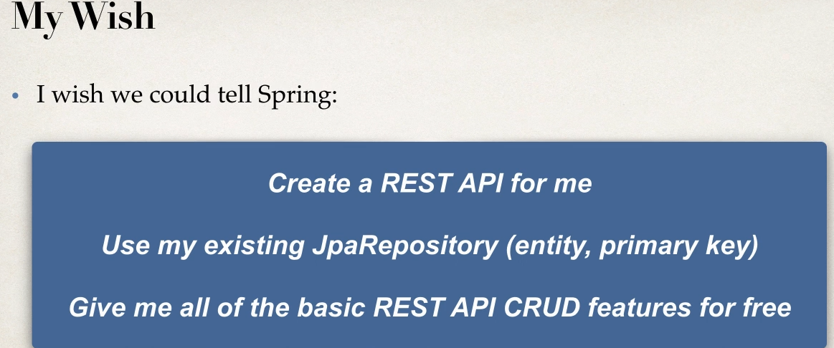

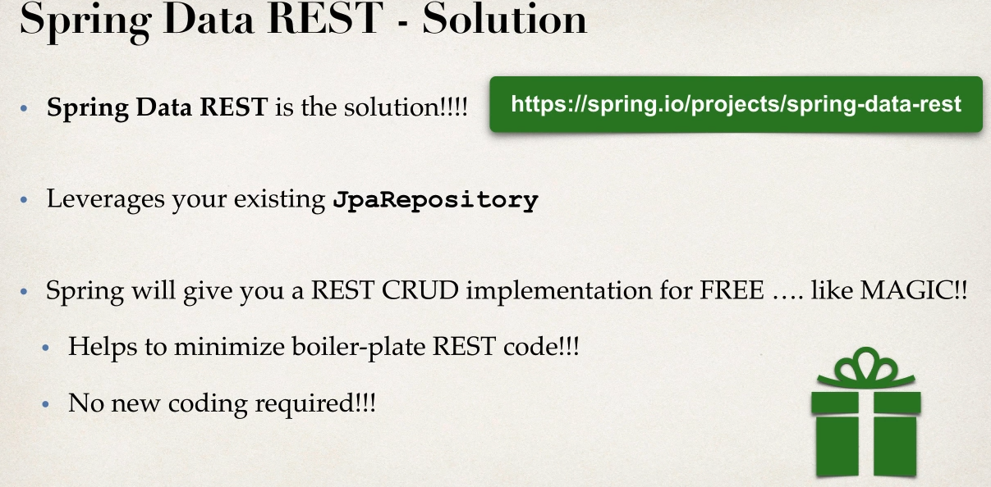

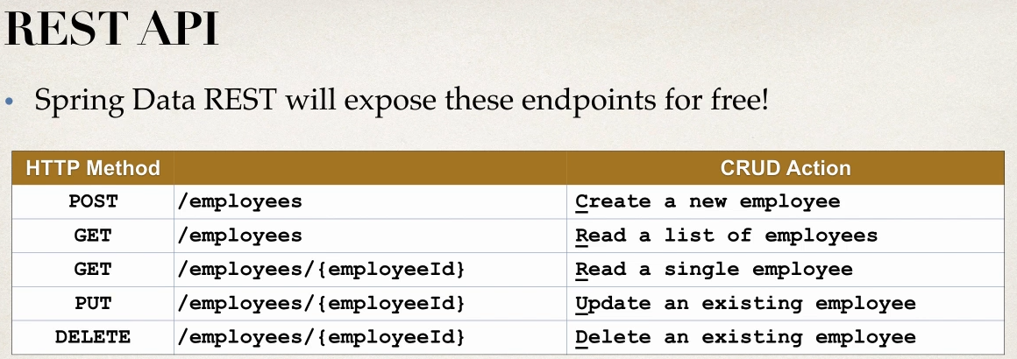

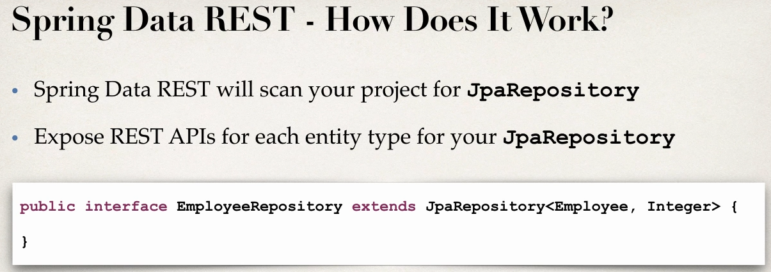

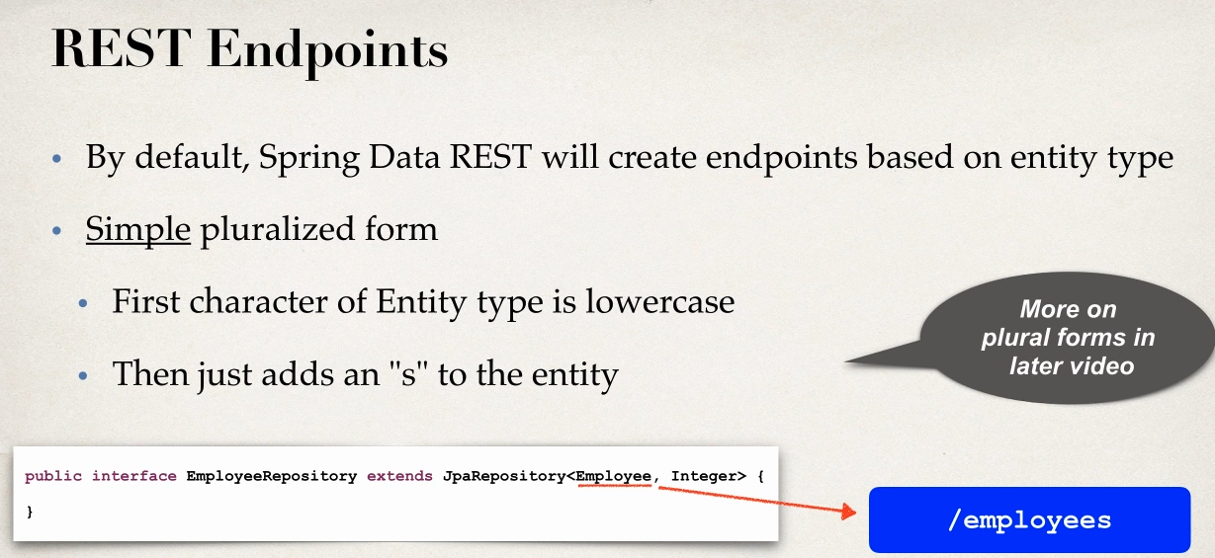

Development Process

1 Adding Spring DAta to MAven POM file

That is no code required

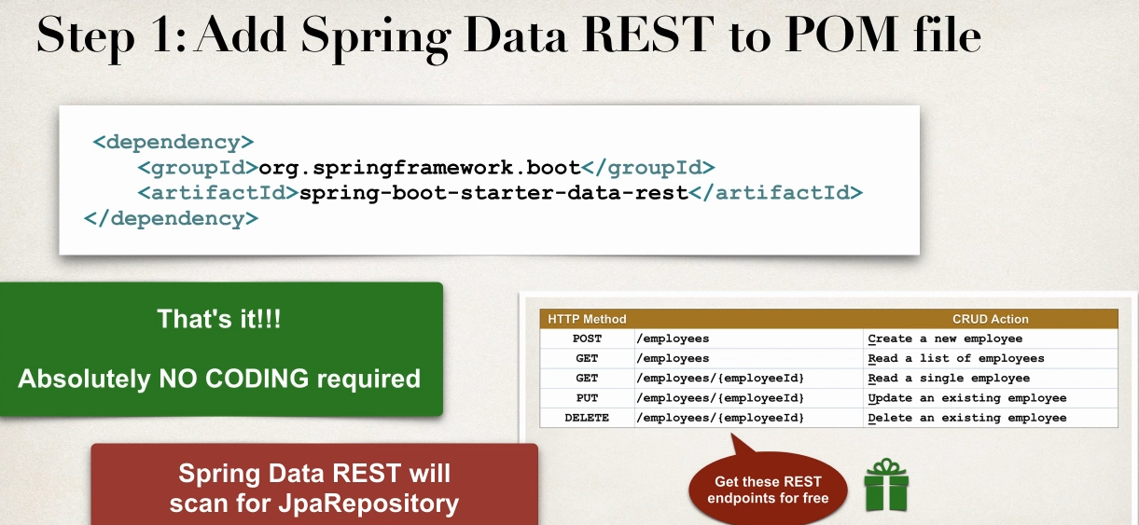

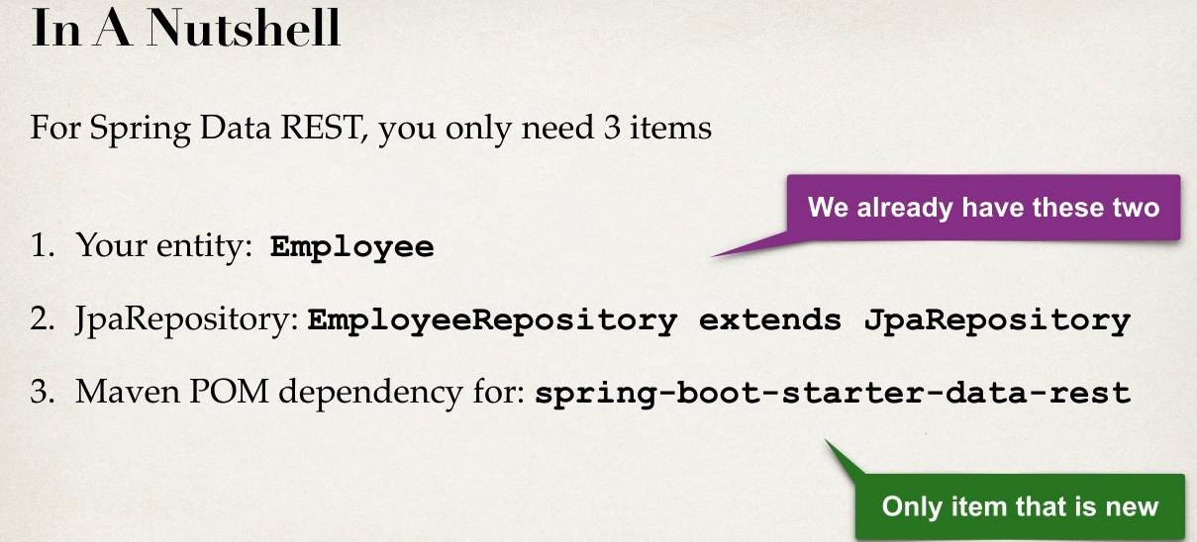

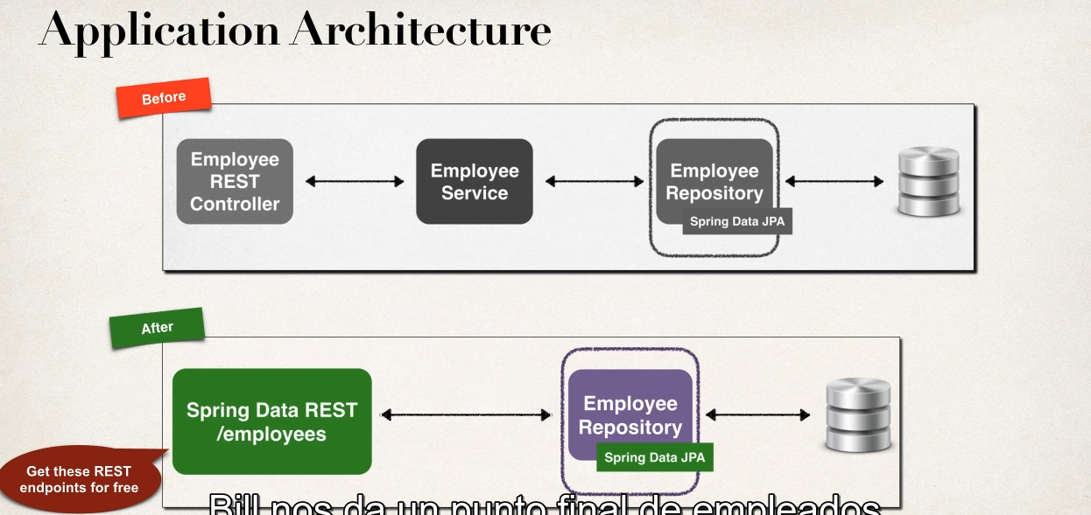

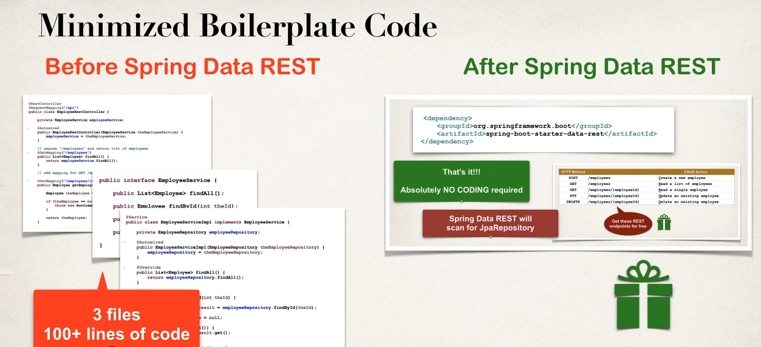

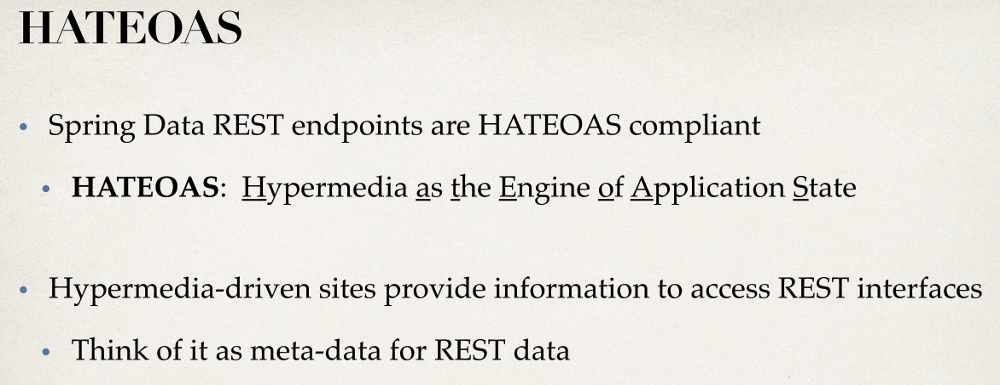

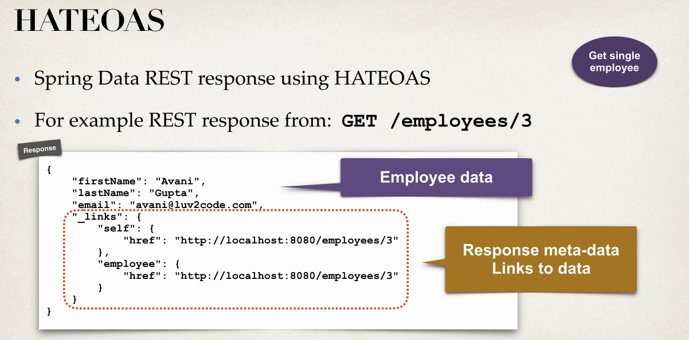

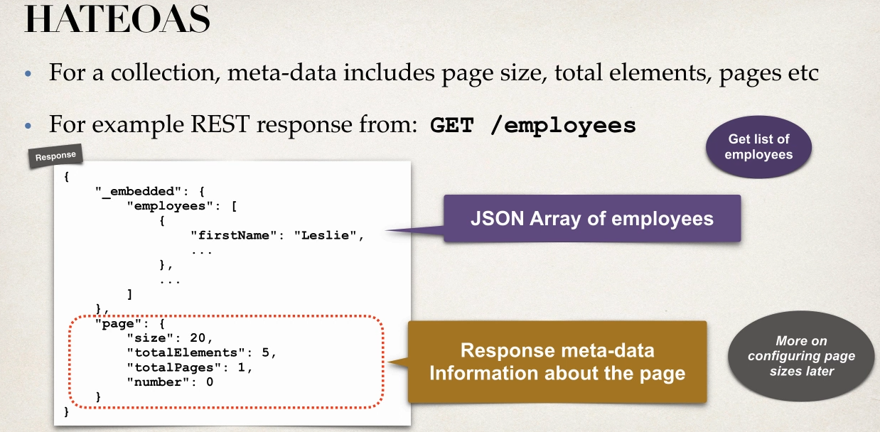

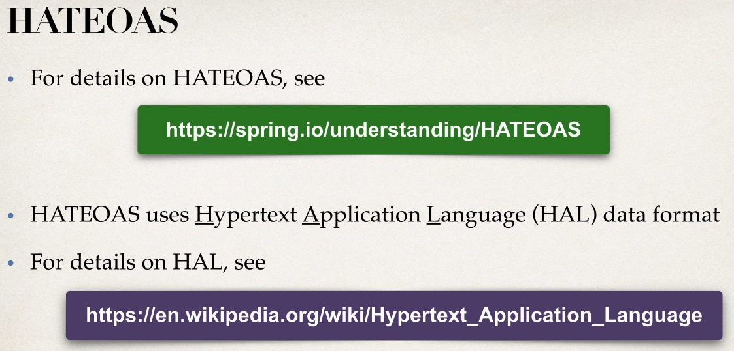

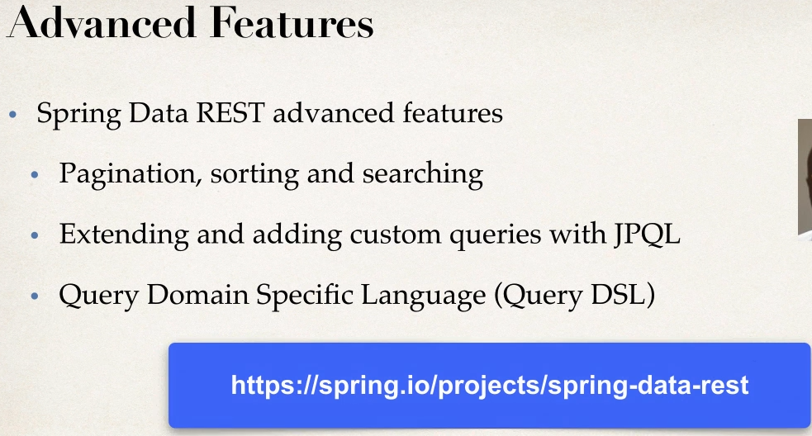

After adding spring-data-rest dependency can drop contoller and service package lets use new table to undestand

Customer Table create entity and JPA repostory for it rest spring-data-rest will handle

Url: http://localhost:8181/BootRestCrm/customers

{

  "_embedded": {

    "customers": [

      {

        "firstName": "sachin",

        "lastName": "hs",

        "email": "sachin.hs@bcits.in",

        "_links": {

          "self": {

            "href": "http://localhost:8181/BootRestCrm/customers/1"

          },

          "customer": {

            "href": "http://localhost:8181/BootRestCrm/customers/1"

          }

        }

      },

      {

        "firstName": "soumya",

        "lastName": "indi",

        "email": "soumya.indi@bcits.in",

        "_links": {

          "self": {

            "href": "http://localhost:8181/BootRestCrm/customers/2"

          },

          "customer": {

            "href": "http://localhost:8181/BootRestCrm/customers/2"

          }

        }

      },

      {

        "firstName": "darshan",

        "lastName": "gowdah",

        "email": "darshan@bcits.in",

        "_links": {

          "self": {

            "href": "http://localhost:8181/BootRestCrm/customers/3"

          },

          "customer": {

            "href": "http://localhost:8181/BootRestCrm/customers/3"

          }

        }

      },

      {

        "firstName": "manasa",

        "lastName": "gowda",

        "email": "manasa@bcits.in",

        "_links": {

          "self": {

            "href": "http://localhost:8181/BootRestCrm/customers/4"

          },

          "customer": {

            "href": "http://localhost:8181/BootRestCrm/customers/4"

          }

        }

      },

      {

        "firstName": "sachin",

        "lastName": "subramanya H S",

        "email": "sachinsubramanya@bcits.in",

        "_links": {

          "self": {

            "href": "http://localhost:8181/BootRestCrm/customers/11"

          },

          "customer": {

            "href": "http://localhost:8181/BootRestCrm/customers/11"

          }

        }

      },

      {

        "firstName": "sachin",

        "lastName": "subramanya H S",

        "email": "sachinsubramanya@bcits.in",

        "_links": {

          "self": {

            "href": "http://localhost:8181/BootRestCrm/customers/12"

          },

          "customer": {

            "href": "http://localhost:8181/BootRestCrm/customers/12"

          }

        }

      },

      {

        "firstName": "Dhanvit",

        "lastName": "Gowda",

        "email": "diyan@gmail.com",

        "_links": {

          "self": {

            "href": "http://localhost:8181/BootRestCrm/customers/5"

          },

          "customer": {

            "href": "http://localhost:8181/BootRestCrm/customers/5"

          }

        }

      }

    ]

  },

  "_links": {

    "self": {

      "href": "http://localhost:8181/BootRestCrm/customers{?page,size,sort}",

      "templated": true

    },

    "profile": {

      "href": "http://localhost:8181/BootRestCrm/profile/customers"

    }

  },

  "page": {

    "size": 20,

    "totalElements": 7,

    "totalPages": 1,

    "number": 0

  }

}

Since we can change base path In application level:

spring.data.rest.base-path=/auto-api

<http://localhost:8181/BootRestCrm/auto-api/customers/1>

Access application Like this

{

  "firstName": "sachin",

  "lastName": "hs",

  "email": "sachin.hs@bcits.in",

  "_links": {

    "self": {

      "href": "http://localhost:8181/BootRestCrm/auto-api/customers/1"

    },

    "customer": {

      "href": "http://localhost:8181/BootRestCrm/auto-api/customers/1"

    }

  }

}

Try POST also using same API

URL: http://localhost:8181/BootRestCrm/auto-api/customers

POST {"firstName":"diyan","lastName":"gowda","email":"diyan.hd@bcits.in"}

Result: Works

For PUT / update use ID in URL not in Body

Bcz spring-data-rest uses only ID in the URL

URL:http://localhost:8181/BootRestCrm/auto-api/customers

PUT : {"id":14,"firstName":"diyan","lastName":"gowda","email":"diyan.hassan@bcits.in"}

Result :fail

Solution

URL:http://localhost:8181/BootRestCrm/auto-api/customers/14

PUT : {"firstName":"diyan","lastName":"gowda","email":"diyan.hassan@bcits.in"}

Result :works

Try Delete

DELETE

http://localhost:8181/BootRestCrm/auto-api/customers/14

No response it wil give simply response code :204

Spring DATA REST Configurtaion,pagination,Sorting

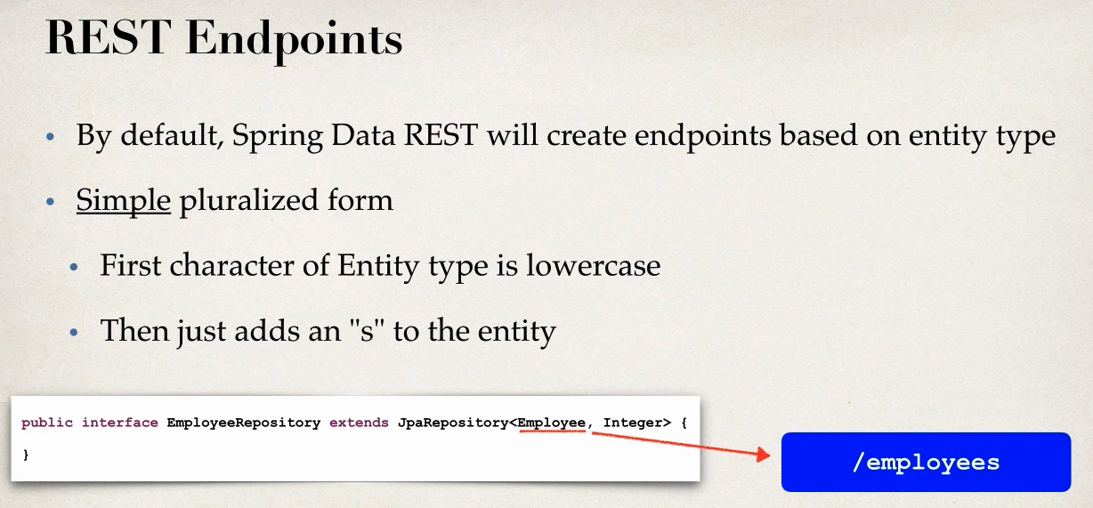

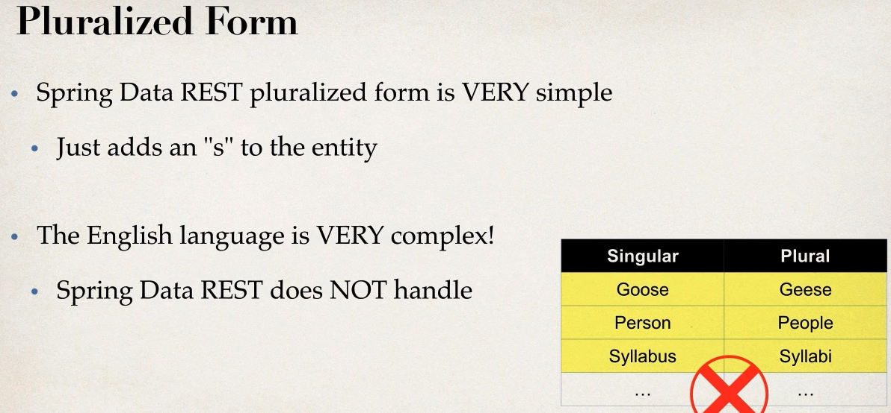

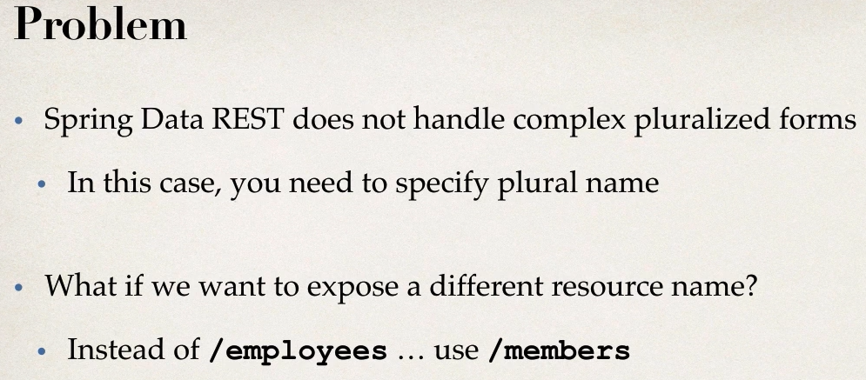

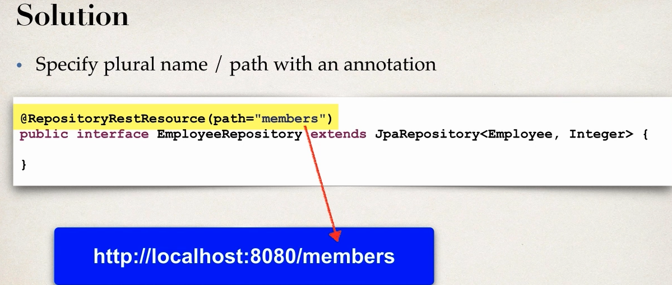

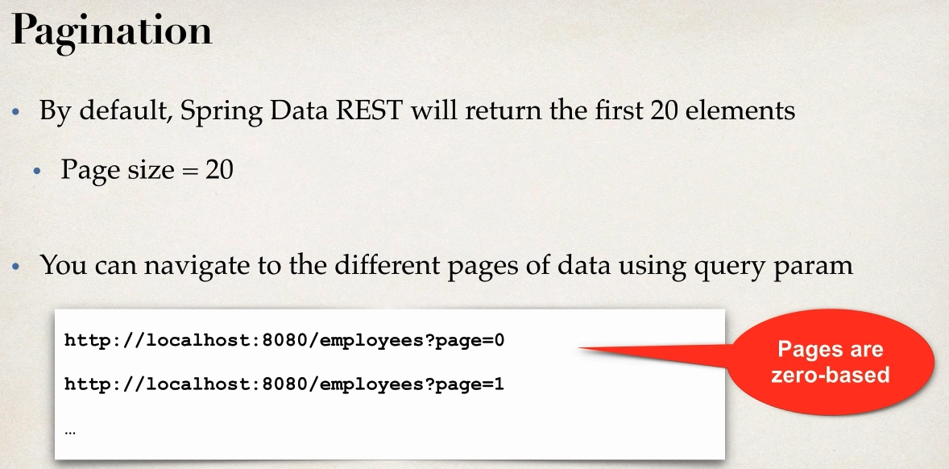

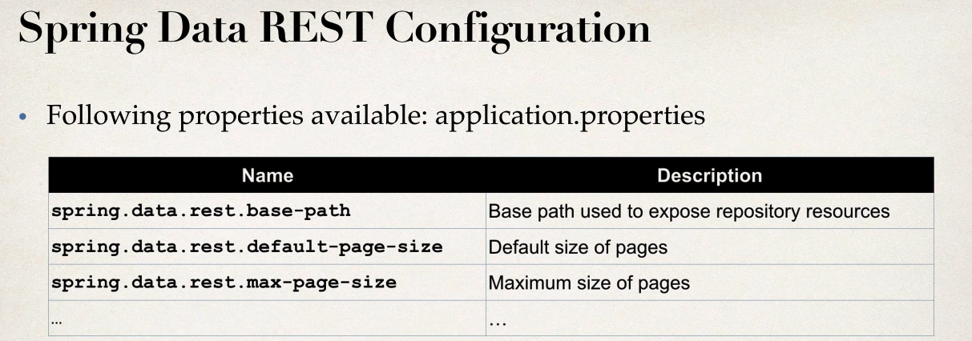

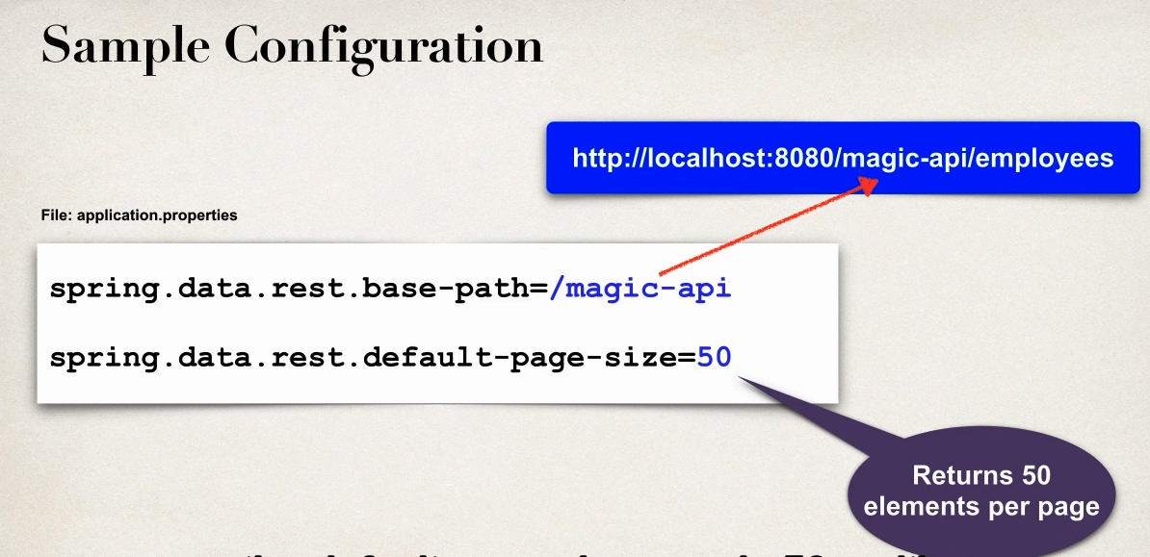

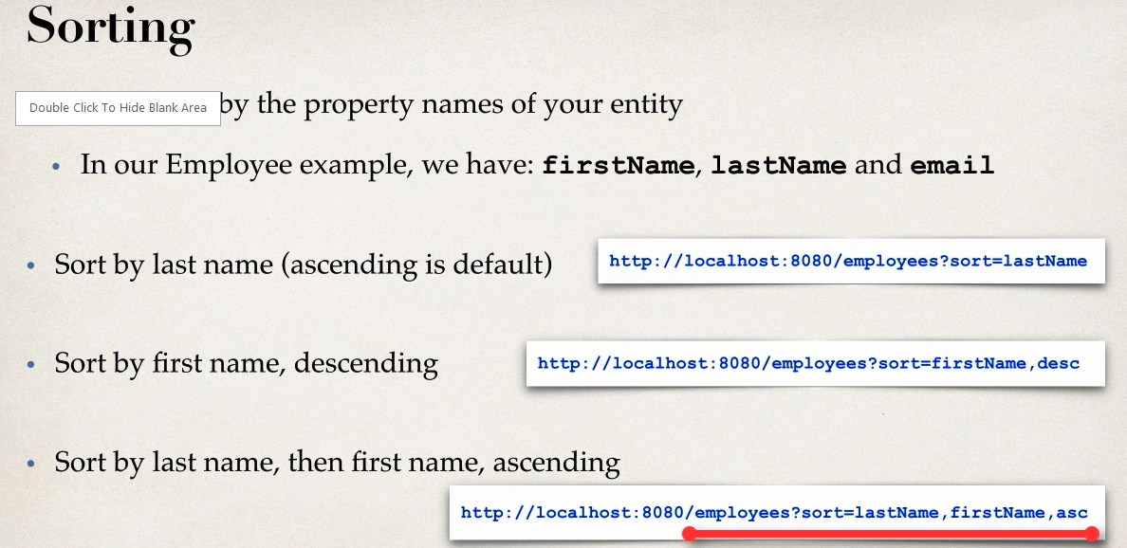

- asc is not required by default it will be default

spring.data.rest.base-path=/auto-api

spring.data.rest.default-page-size=2

http://localhost:8181/BootRestCrm/auto-api/custmembers?sort=lastName

<http://localhost:8181/BootRestCrm/auto-api/custmembers?sort=lastName,desc>

<http://localhost:8181/BootRestCrm/auto-api/custmembers?sort=lastName,firstName,asc>

Spring BOOT THYMELEAF

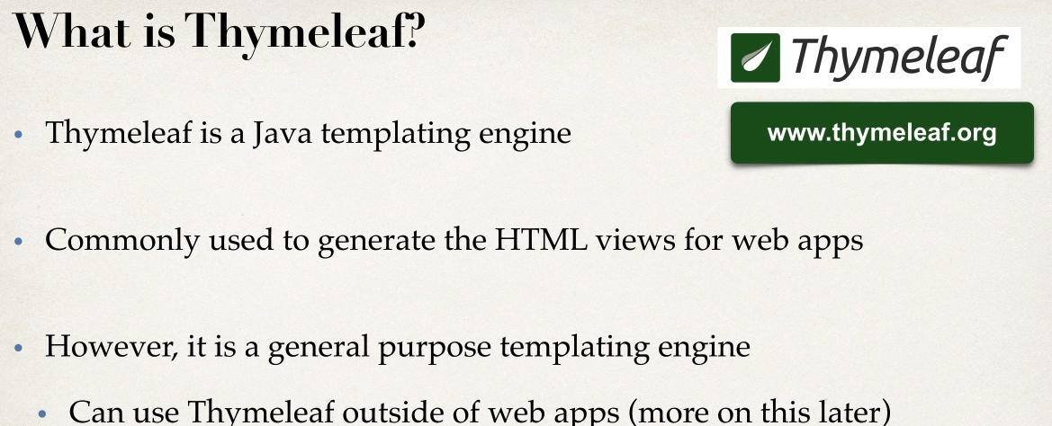

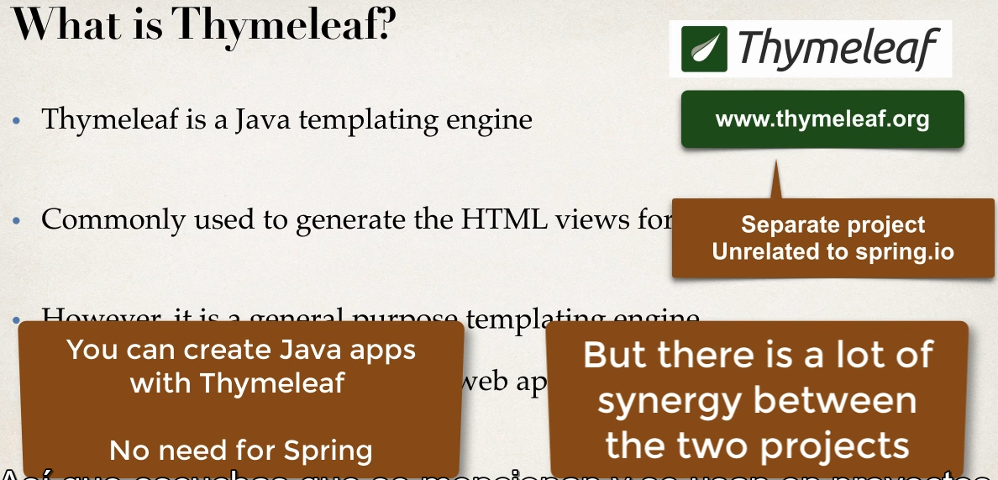

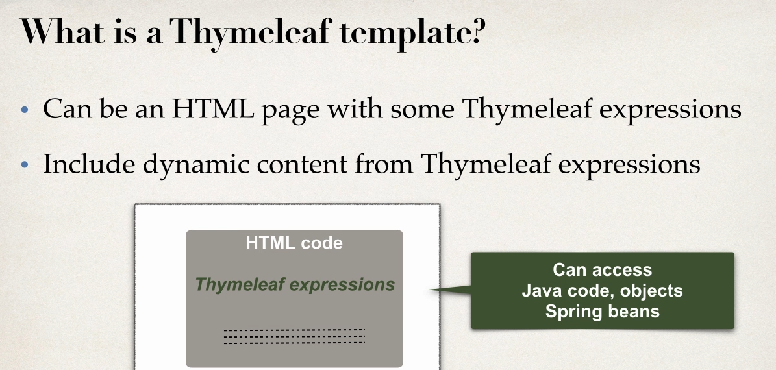

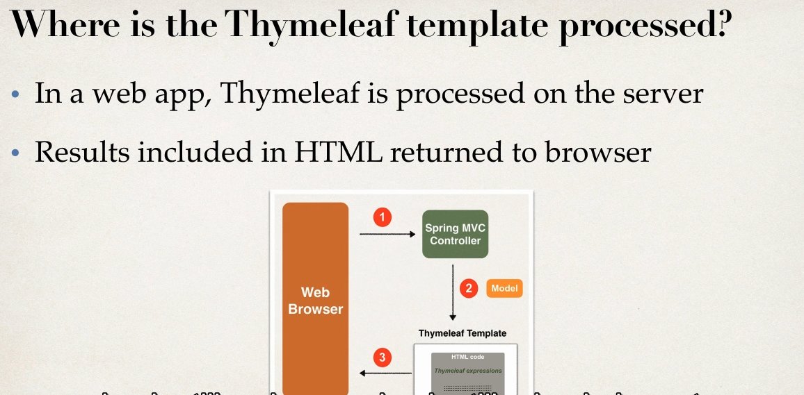

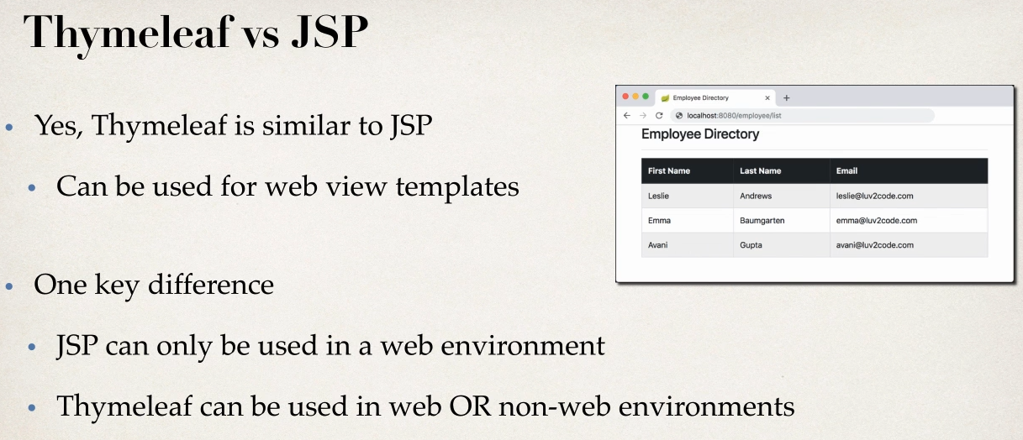

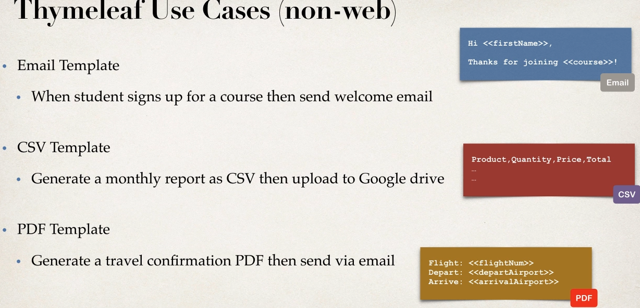

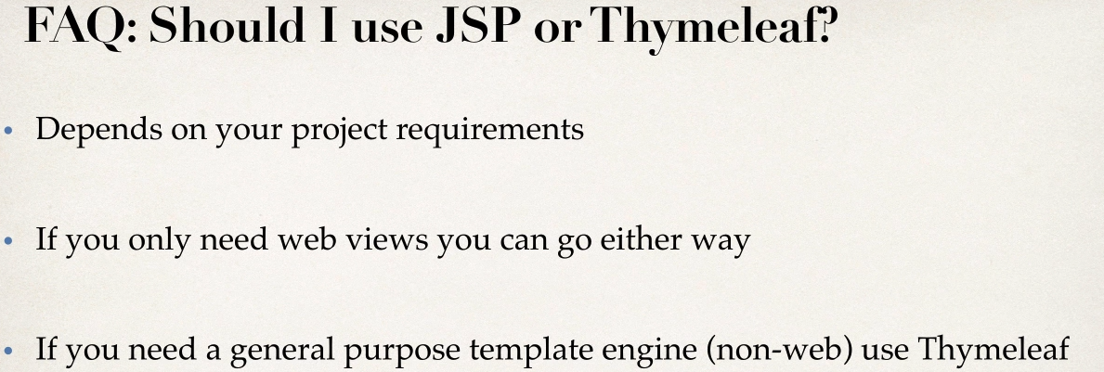

Development Process

1 Add Thymeleaf to MAVEN POM file

2 create controller

3 create Thymeleaf template

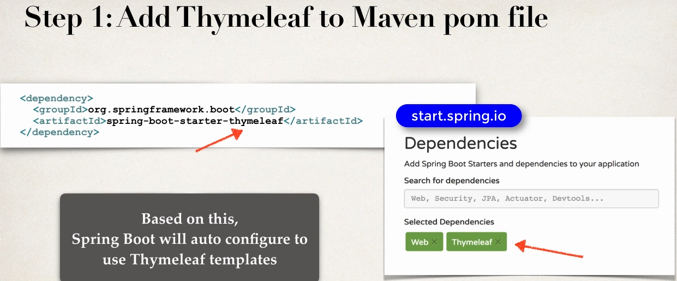

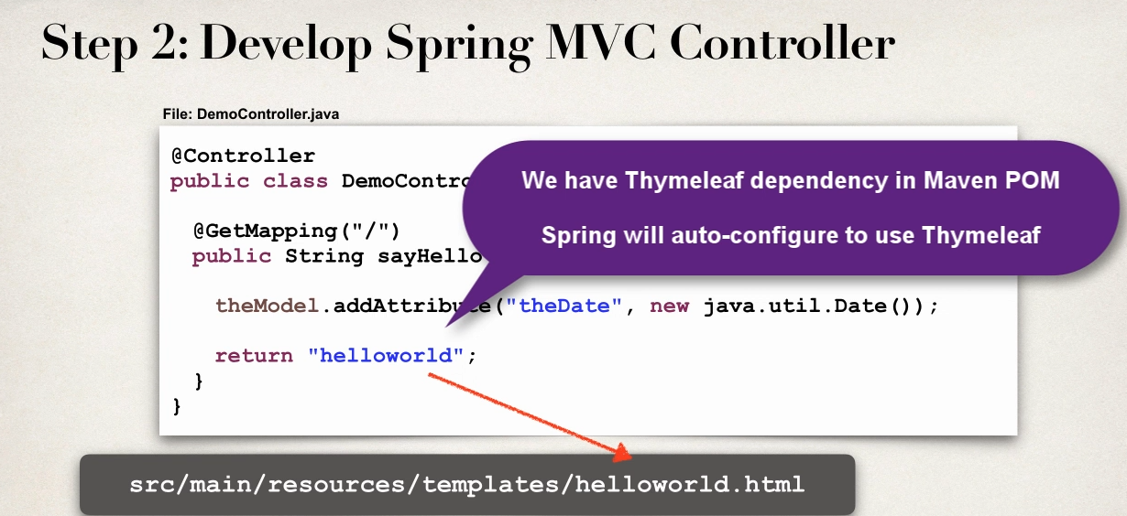

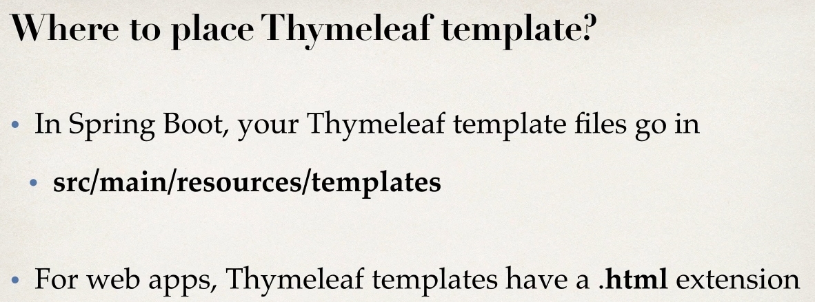

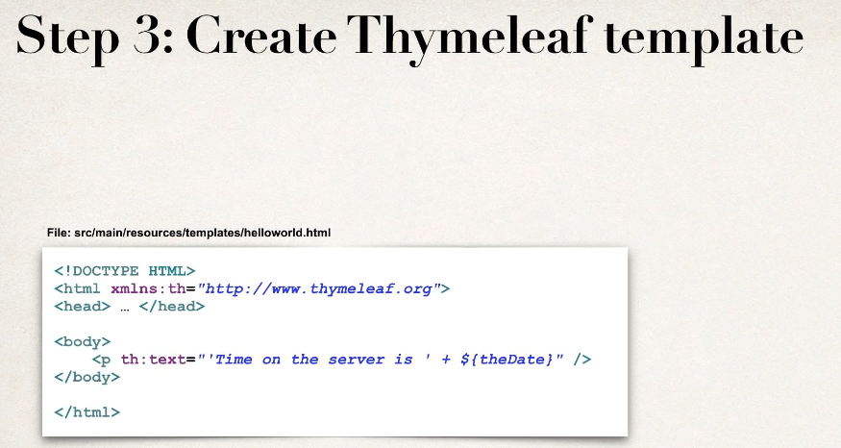

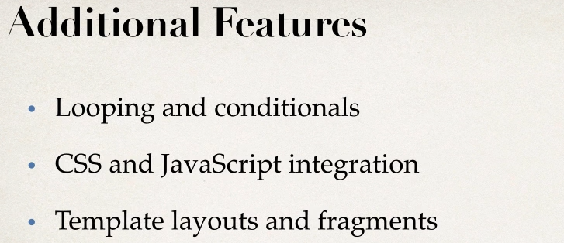



Development Process

1 create CSS file

2 Referenece css in THYMLEAF tmeplate

3 apply css style

